DBMS ASSIGNMENT 2

1)ER DIAGRAM

2)

A)TOP 3 DEPARTMENT WITH HIGHEST AVG SALARY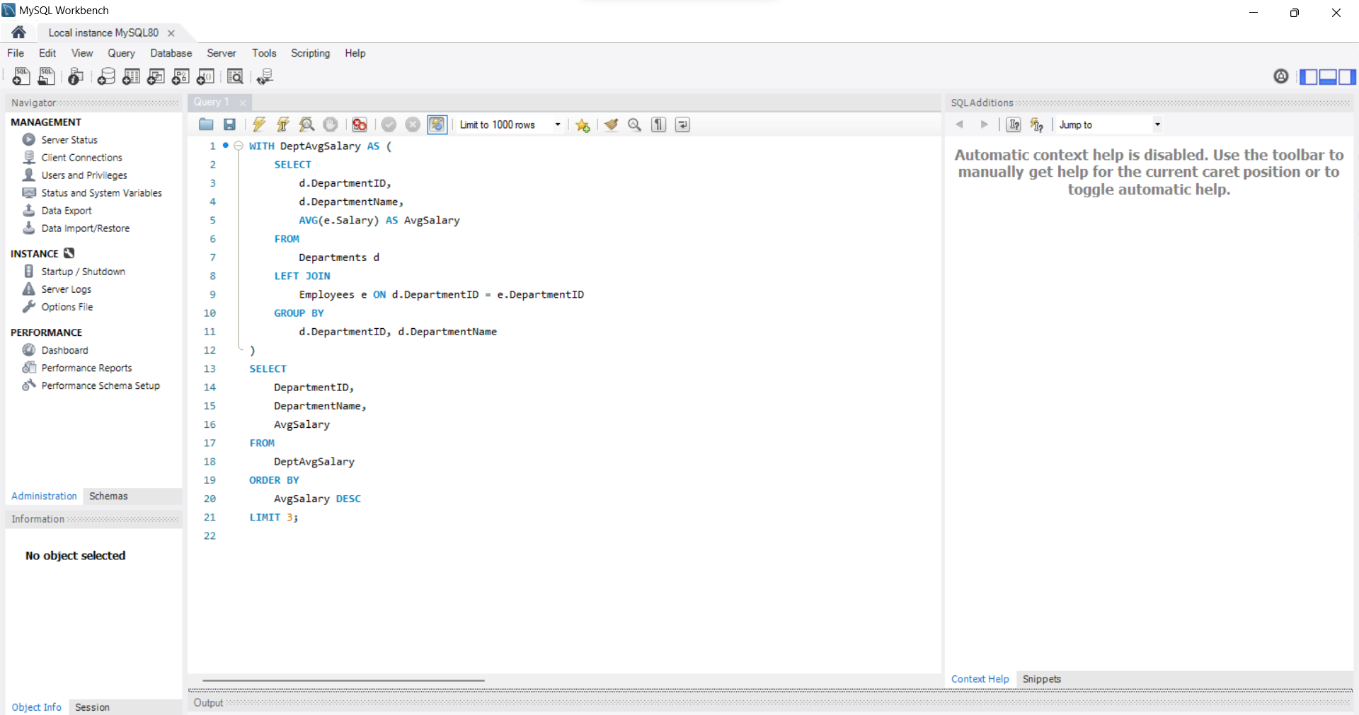

B)RETRIEVING HIERACRCHICAL CATEGORY PATH

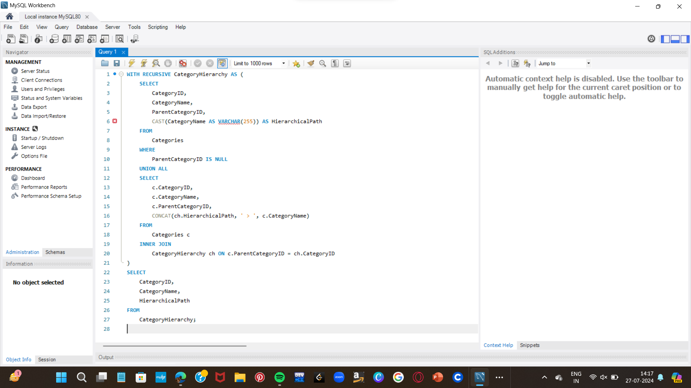

C)TOTAL DISTINCT CUSTOMERS BY MONTH

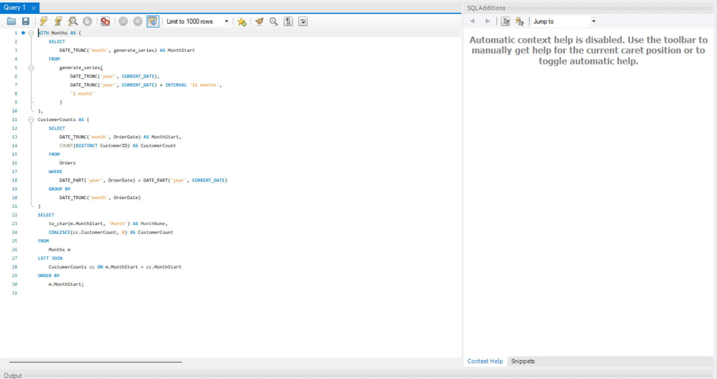

D)FINDING CLOSEST LOCATION

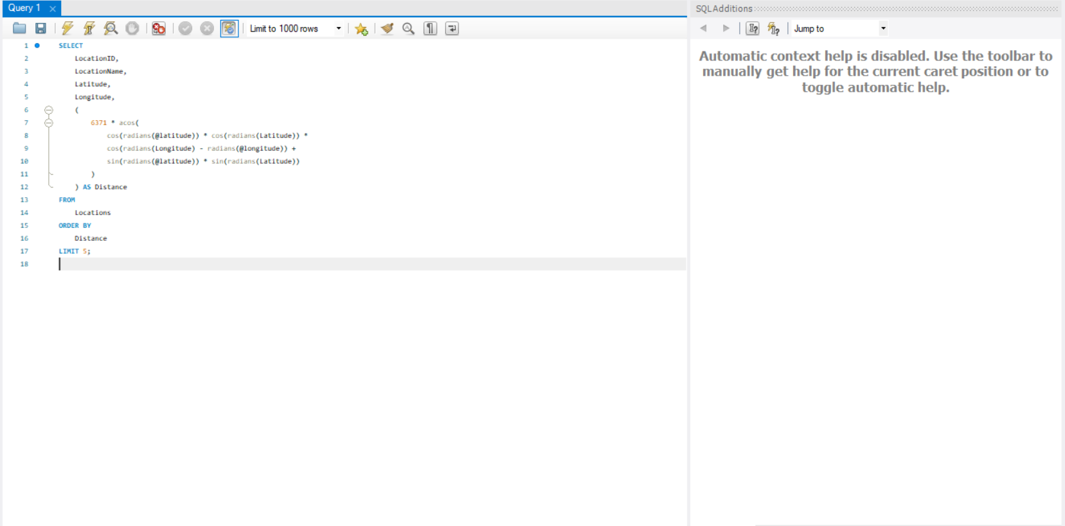

E)OPTIMISING QUERY FOR ORDER TABLE

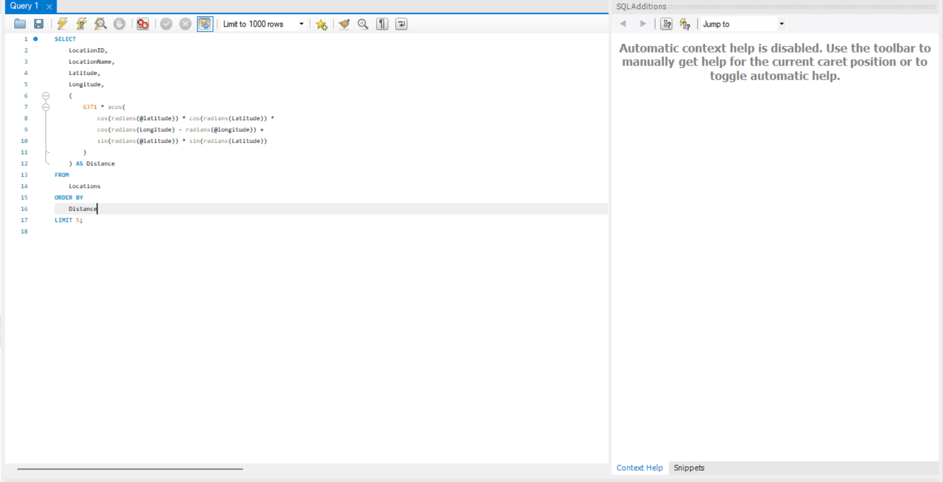

3)HANDLING DIVISION OPERATION:

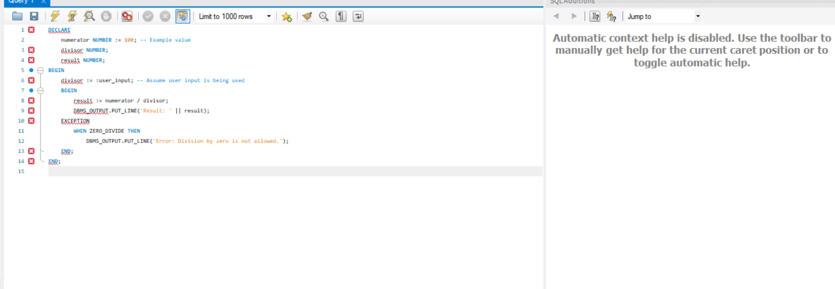

4)UPDATING ROWS FOR ALL

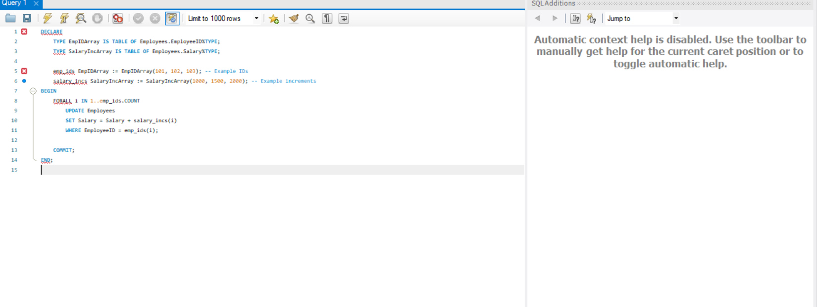

5)IMPLEMENTING NESTED TABLE PROCEDURE:

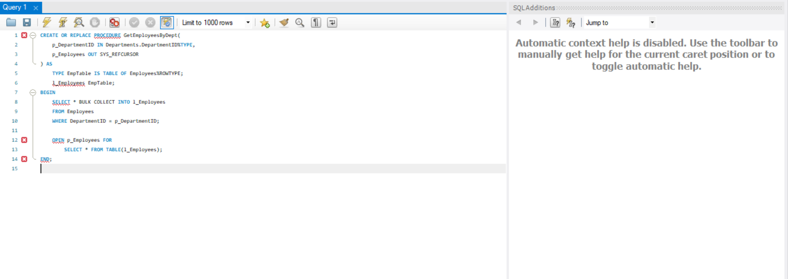

6)USING CURSOR VARIABLE AND DYNAMIC SQL

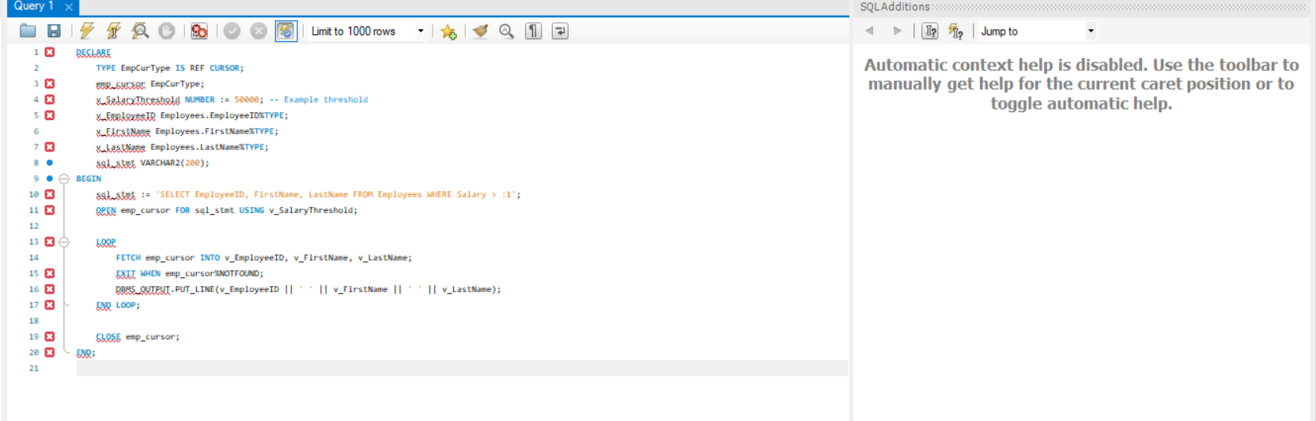

7)DESIGNING PIPELINE FUNCTION FOR SALES

